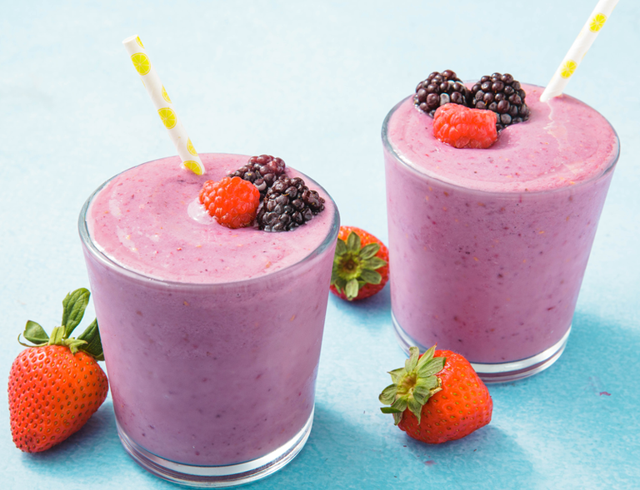Healthy Fruit smoothie recipe by: FM

|  |  |
| --- | --- |
| **Introduce your recipe.** What is good about it? Can you persuade others to try it? | This is my Smoothie recipe, it is meant to wake you up  And make you feel good to start the day made with some very unusual ingredients. |
| The ingredients (food) you will need are: | 1. First you will need, Frozen strawberry,banana,papaya,mango and pineapple preferably from Sainsbury’s  2. Secondly, 200ml of semi skimmed milk.  3.next, 1teaspoon and a half of honey we used rouse which help protect bees and beekeepers.  4. some frozen blueberries and blackberries  Also from Sainsbury’s  5.finally, SOME PORRIDGE OATS. |
| The equipment your will need are: | 1. Blender 2. Measuring jug 3. bowls 4. glass |
| Method. The steps to make your smoothie. | 1. Pour all the frozen fruit in the blender along with the oats. 2. Pour your milk into the blender      1. Finally mix it all up until creamy pour some into a glass and enjoy the taste of the F delicious see who needs all these ice cream toffee ‘*whub a dubba’* smoothies when you've got the healthy (and just as delicious) version right in front of you. |